# Watsonx Orchestrate Lab 1:

# Out of the Box Skills

Objective:

Welcome to watsonx Orchestrate Lab. Watsonx Orchestrate runs on applications and skills. To start off, we will walk through how to connect and use the out of the box skills and use it within the AI Chat.

Use Case:

In this lab, you will learn how to connect to salesforce with watsonx orchestrate, add prebuilt skills of salesforce and how to use in AI chat. Credentials for this lab can be found here.

Connecting to watsonx Orchestrate

1. Login to watsonx Orchestrate using your IBM Cloud email id and password. If you have trouble locating your username and password, please contact an IBM-er.

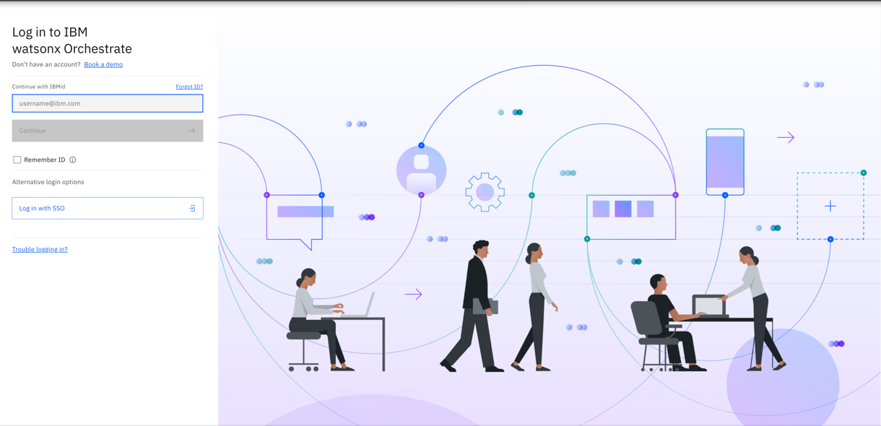

1. You will land on watsonx Orchestrate homepage. Click on Skill Studio.

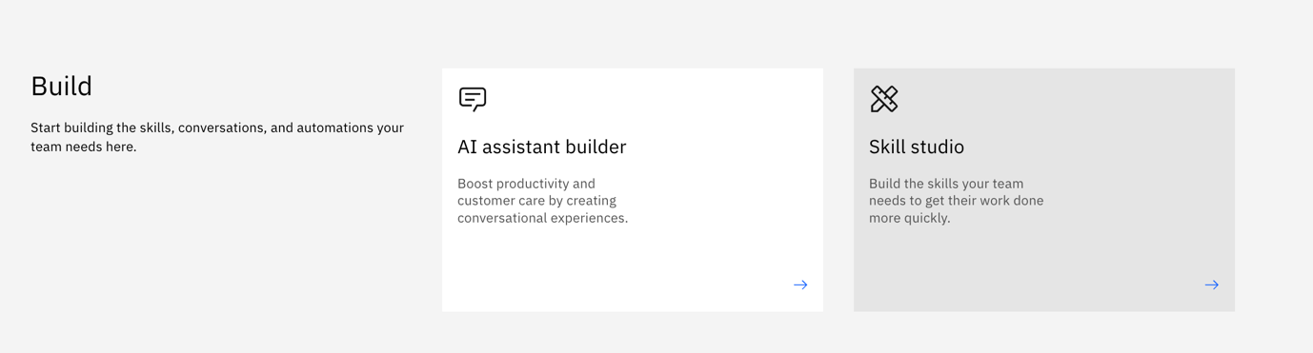

1. Click on the “Skills and apps” tab and “Configure prebuilt skills”.

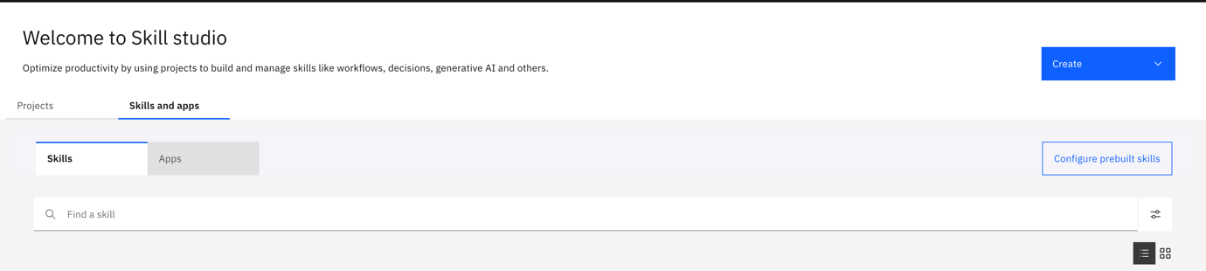

1. Click on “Salesforce” and click “Connect App”.

1. You can skip the “Custom URL” portion and click “Update App”. You will be brought to a Salesforce login page. Use the credentials given to you and authorised all access.
2. After the connection is established, we will load in the skills needed for this scenario. Search for “Get all accounts” and “Get all Products” from prebuilt skills and configure them.

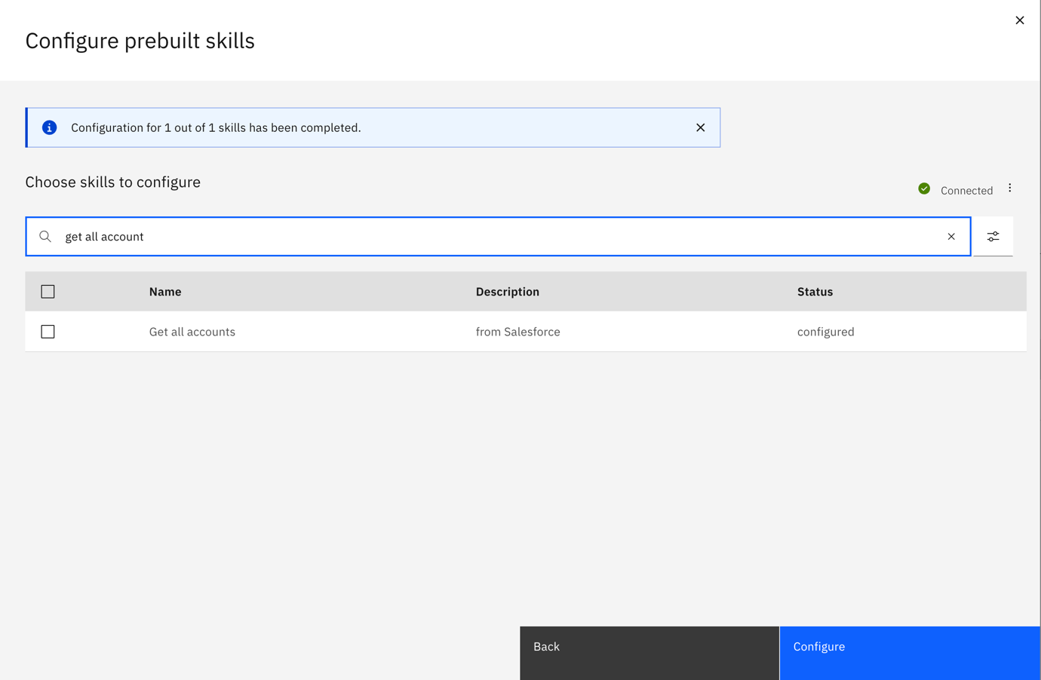

1. After the configuration is done, you should be able to see the skills in the Skills and apps list.

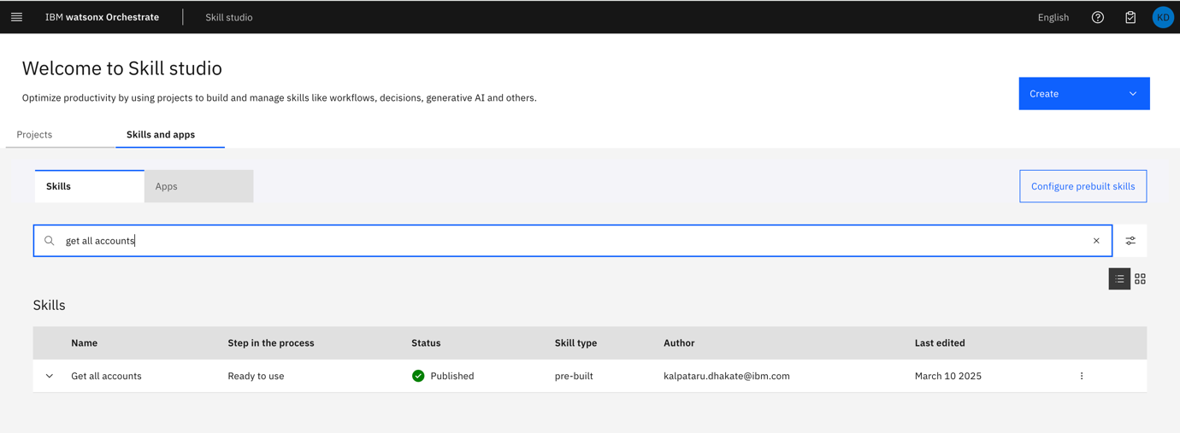

1. A screenshot of a computer

   AI-generated content may be incorrect.Go to Skill catalog from the side menu and search for “Salesforce”.
2. Search for the published skill i.e. “Get all accounts”, “Get all product” and click on “Add Skill”.
3. Try to connect to the Send an email skill from Gmail on your own.

Configure AI Agent with Custom Skill

Note:

Up until 12 March 2025, only admins can configure AI agents within a tenant.

Only proceed if you have admin access.

1. Go to “Skill Sets” from the top left hamburger menu.

1. From the dropdown menu select “Orchestrate Agent Skillset”

1. Move to the Connections tab and search for “Salesforce” and select “Connect app”



1. Select “Team Credentials” and click on “Connect app”.
2. Skip the Custom URL and you will be forwarded to a Salesforce log in page.
3. Use the given credentials to login and give access to all methods.
4. Once you are directed back to the skillset page, you should the Salesforce connection details is update.



1. Navigate to the AI Agent Configuration from the left hamburger menu.

1. Select “Apps and Skills” and search for Salesforce. Click on the Salesforce tile.

1. Search for “Get All Product” and click “Add to chat”. A screenshot of a computer

   AI-generated content may be incorrect.
2. Give a description to this skill and click “Add Skill”. Be as descriptive.

1. Repeat steps 10 and 11 to add “Get all accounts” to the configuration.
2. Now, you are ready to use “Get all accounts” skills in your AI chat. Click on chat option. Type skill name and you can see the response. You can use these skills in your assistant. Click on new chat, type in chat “get all accounts”.

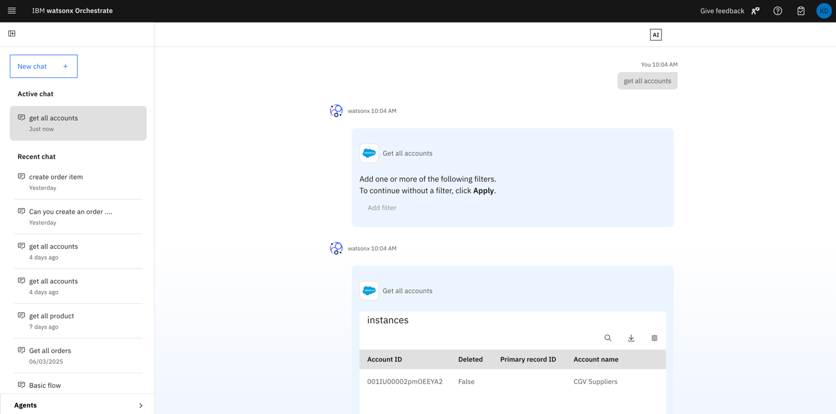

1. In addition to adding pre-built skills, you can create and integrate your own custom skills into Watsonx Orchestrate. For guidance on importing custom skills, refer to Lab1b.